# **Apache Upgradation on Linux server**

This article assumes you have an existing server (real or virtual) with Apache installed on it.

Here are the steps to upgrade Apache Services:

1. Download Apache latest version from <https://httpd.apache.org/download.cgi>.

pcre2 <https://www.pcre.org/>

Apr, Apr-util, APR-iconv <https://apr.apache.org/>

[Expat](https://github.com/libexpat/libexpat/blob/R_2_6_2/expat/Changes) <https://libexpat.github.io/>. (Download tar.gz file)

1. Copy the file to the tmp folder of the server.

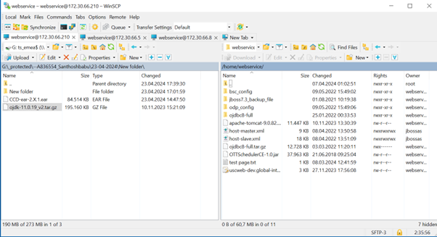

1. Login using root user.
2. Grep the httpd service and check the path.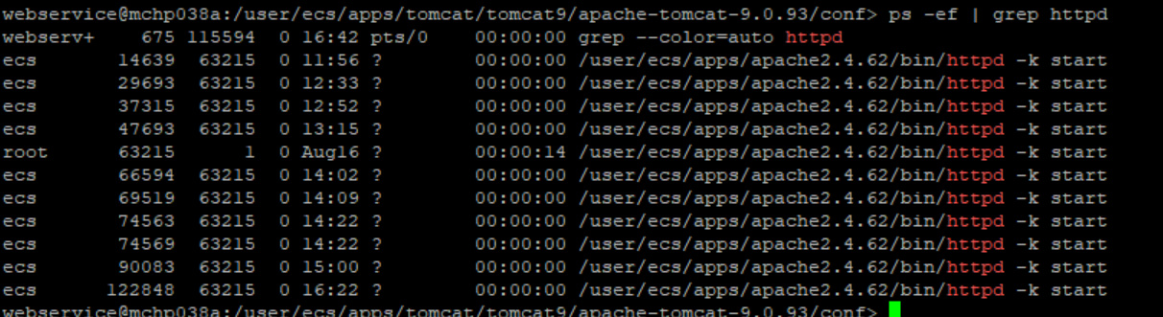
3. Navigate to the path.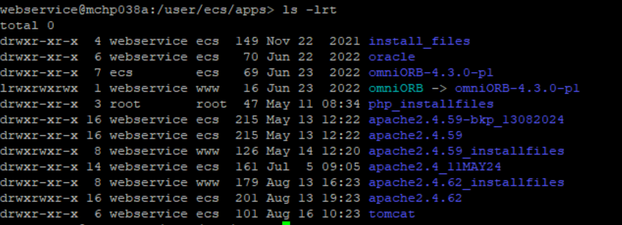
4. Create a folder named Apache_installfiles.
5. Copy the downloaded files to this folder and untar it.

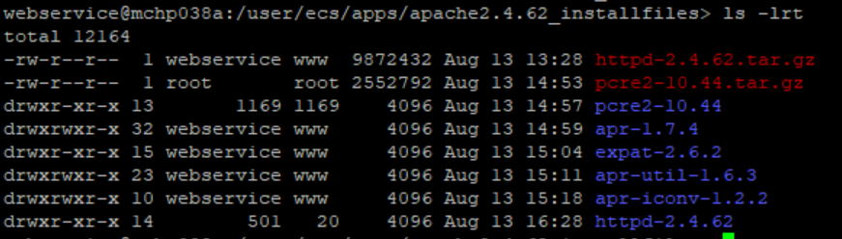

1. Install Pcre2 using below sudo codes.

cd pcre2-10.42

./configure --prefix=/apps/apache2.4.59_installfiles/pcre2-10.42

make

make install

1. Install APR:

cd APR-xxxx

./configure --prefix=/user/ecs/apps/apache2.4.62_installfiles/apr-1.7.4

make

make install

1. Install APR utilities:

cd apr-utilities-xxxx

./configure --prefix=/user/ecs/apps/apache2.4.62_installfiles/apr-util-1.6.3 --with-apr=

make

make install

1. Install APR iconv:

cd apr-iconv-xxxx

./configure --prefix=/storage/apr-iconv --with-apr=/storage/apr/ --with-apr-util=/storage/apr-util/ --with-pcre=/storage/pcre

make

make install

1. Install Apache:

cd httpd-2.4

./configure --prefix=/storage/apache2.4 --enable-mods-shared=all --with-mpm=prefork --enable-ssl --with-apr-util=/apps/apr-util --with-apr=/apps/apr --with-apr=/apps/pcre --with-ssl --enable-so

make

make install

1. You can find the new apache folder is created.

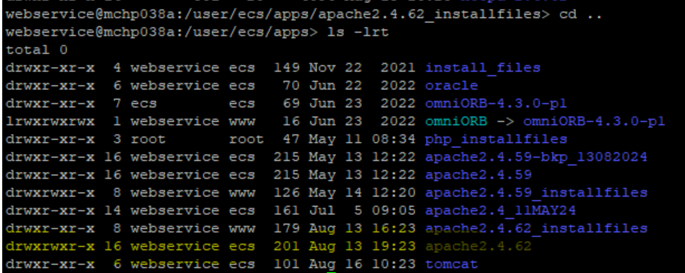

1. Change the ownership of the new apache files created.

chown –R sisladm:www /storage/apache2.4

1. Give read and write permissions to the files.

chmod –R 775 /storage/apache2.4

1. Change the path to new apache folder in the httpd.conf file by using

sed -i "s/find this word /replace this word/g" file name.

1. Test Apache configuration : Navigate to \bin and execute

./apachectl -t

(the output will be “ Syntax Ok”)

1. Stop the running apache services.
2. Reconfigure httpd.services files to latest version path and do daemon restart with the help of linux team.
3. Navigate to bin path and stop the services by executing

./ apachectl -k stop

1. Start the services by executing

./ apachectl -k start

1. Check the version of apache.

